Practical No. 23
Aim : 5) Develop a program using InetAddress class to retrieve IP address of computer when hostname is entered by the user.

Name : Danish Altaf Solkar | Class : CO - B
Enrolment no. : 24111590805 | Batch : 2

Code :-
import java.net.*;
import java.util.*;

public class InetDemo
{
public static void main(String args[]) throws Exception
{
Scanner sc=new Scanner(System.in);
System.out.println("Enter Host Name:");
String hostname=sc.nextLine();
InetAddress ip=InetAddress.getByName(hostname);
System.out.println("HostName:"+ip.getHostName());
System.out.println("HostAddress:"+ip.getHostAddress());
sc.close();
}
}

OUTPUT :-
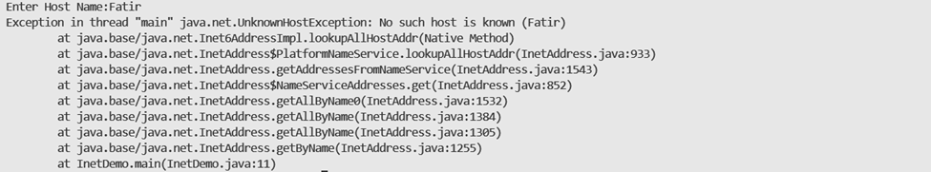
Danish
Danish